Prefix

What is Prefix
# Source: Chatgpt (GPT-4-turbo) at [7/29/2025]
A prefix is a type of affix added to the beginning of a root or base word to create a new word with a modified meaning. Prefixes are a form of derivational or inflectional morphology, though most in English are derivational.

🔹 Definition of Prefix:
# Source: Chatgpt (GPT-4-turbo) at [7/29/2025]
A prefix is a bound morpheme that is attached to the start of a root or base word. It cannot stand alone and is used to alter the meaning of the root.

🔹 Examples of Common Prefixes in English:
# Source: Chatgpt (GPT-4-turbo) at [7/29/2025]
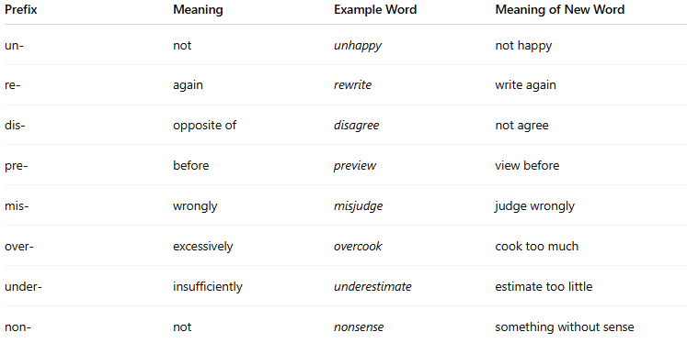
Prefix | Meaning | Example Word | Meaning of New Word
un- | not | unhappy | not happy
re- | again | rewrite | write again
dis- | opposite of | disagree | not agree
pre- | before | preview | view before
mis- | wrongly | misjudge | judge wrongly
over- | excessively | overcook | cook too much
under- | insufficiently | underestimate | estimate too little
non- | not | nonsense | something without sense

🔹 Features of Prefixes:
# Source: Chatgpt (GPT-4-turbo) at [7/29/2025]
- ✅ Appear before the root or stem.
- ✅ Commonly change the meaning, not always the word class.
- ❌ Cannot stand alone (they are bound morphemes).
- ✅ Usually used in derivational morphology.
- ✅ Found in many English and Indo-European languages.

🔹 Prefix vs Other Affixes:
# Source: Chatgpt (GPT-4-turbo) at [7/29/2025]
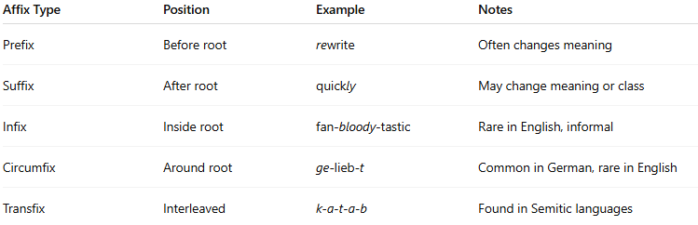
Affix Type | Position | Example | Notes
Prefix | Before root | rewrite | Often changes meaning
Suffix | After root | quickly | May change meaning or class
Infix | Inside root | fan-bloody-tastic | Rare in English, informal
Circumfix | Around root | ge-lieb-t | Common in German, rare in English
Transfix | Interleaved | k-a-t-a-b | Found in Semitic languages

